Chris Ausbun

February 25, 2020

Intro Python Programming

Module 5 Homework Assignment

**To Do Task/Priority Script**

# **Introduction**

The goal of this document and exercise is to work with Dictionaries by create a ToDo list that asks for the Task and Priority of something. When first opening up the script, the ToDo list is converted from a list to a dictionary. Then stores it back into a text document when the changes have been made. In the following documentation, I was able to create everything just from following the “Intro to Python Mod04” video from the instructor (Root, R., Intro to Python Mod01, YouTube, 2019), though this one was quite difficult and it did require getting help while in class as well.

# **Having new variables**

Learned how to create a menu which is just a fancy way of saying a bunch of print statements and an input function for which ever choice they make.

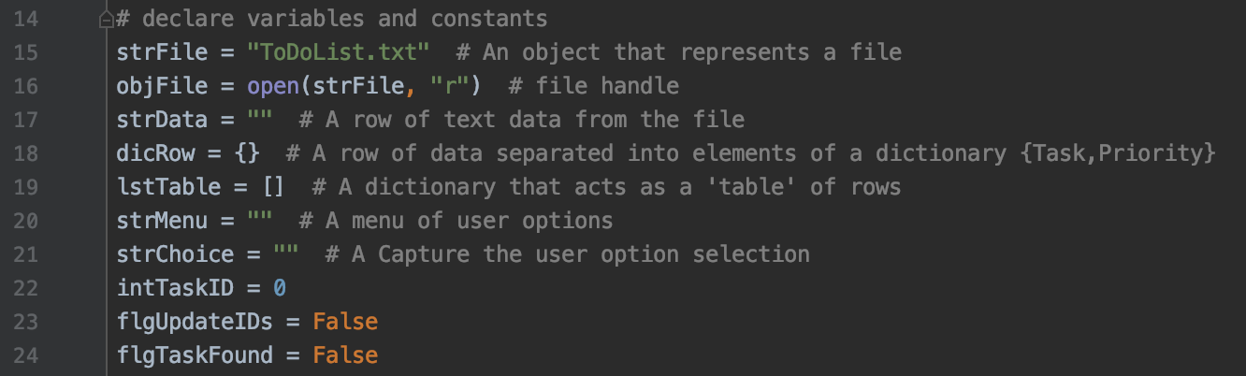

**Figure 1: New Variables**

# **Learning how to convert lists to dictionaries**

Learned how to convert a list from a text document when opening up the script to a dictionary.

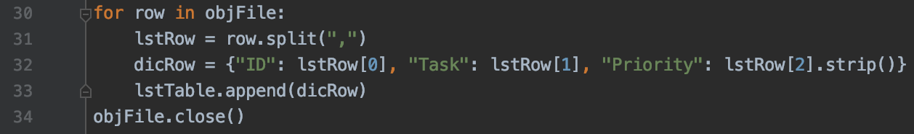

**Figure 2: Converting List to Dictionary**

# **Learning how to implement a for loop**

Learned how to for loop for everything that’s in my objList.

# 

**Figure 3: Adding items to the list**

# **Removing items from a list**

This was the bit I struggled with just trying to learn the syntax and how something needed to be removed from a list.

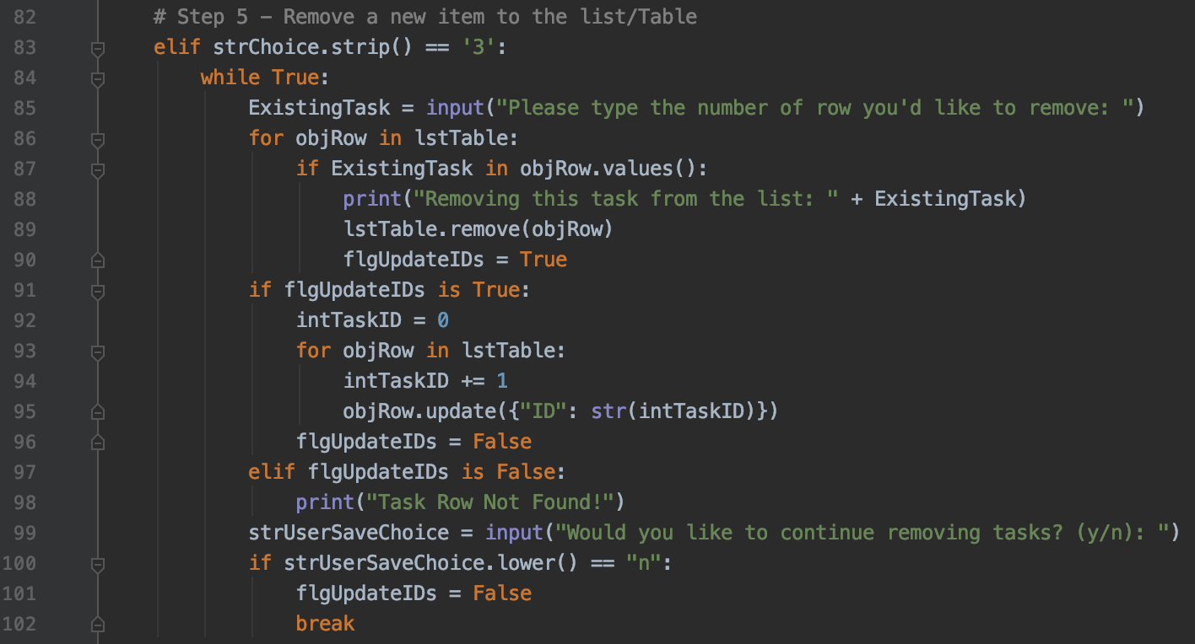

**Figure 4: Removing items from the text file**

# **Summary**

After learning everything with dictionaries, the new variables that allowed me to do more with my dictionary, and how to remove stuff from the list, I was able to create an interactive python script file that gets a user’s tasks and priorities and displays it, adds more to it, and removes items from the list. I’ve added a few screenshots below of it working in PyCharm, Terminal, and shows the output of the text document.

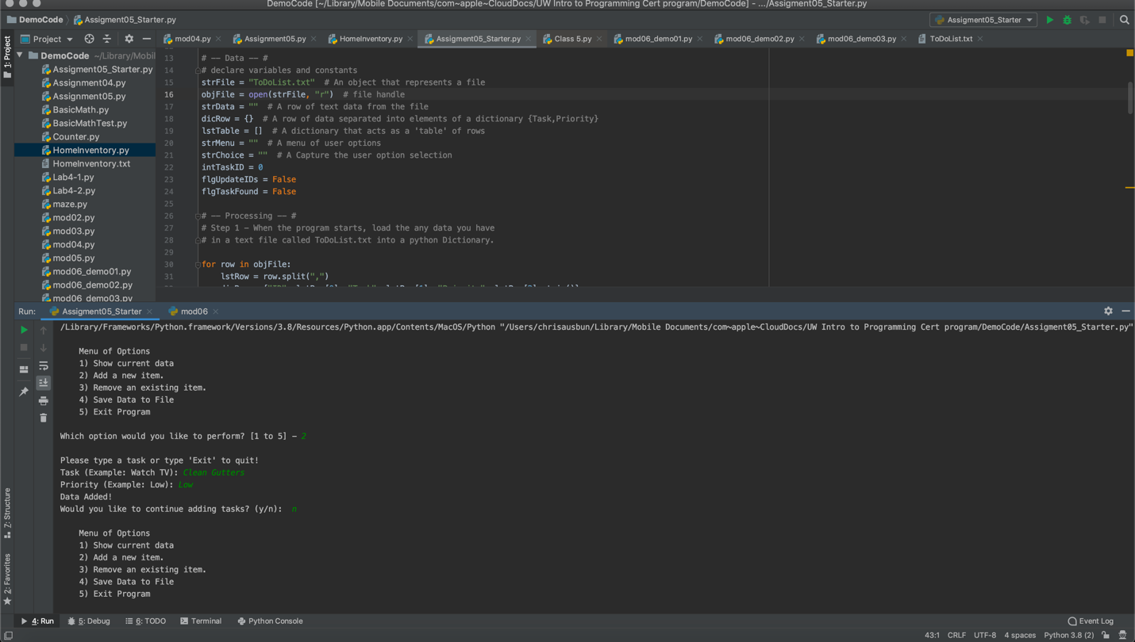

**Figure 5: Running in PyCharm**

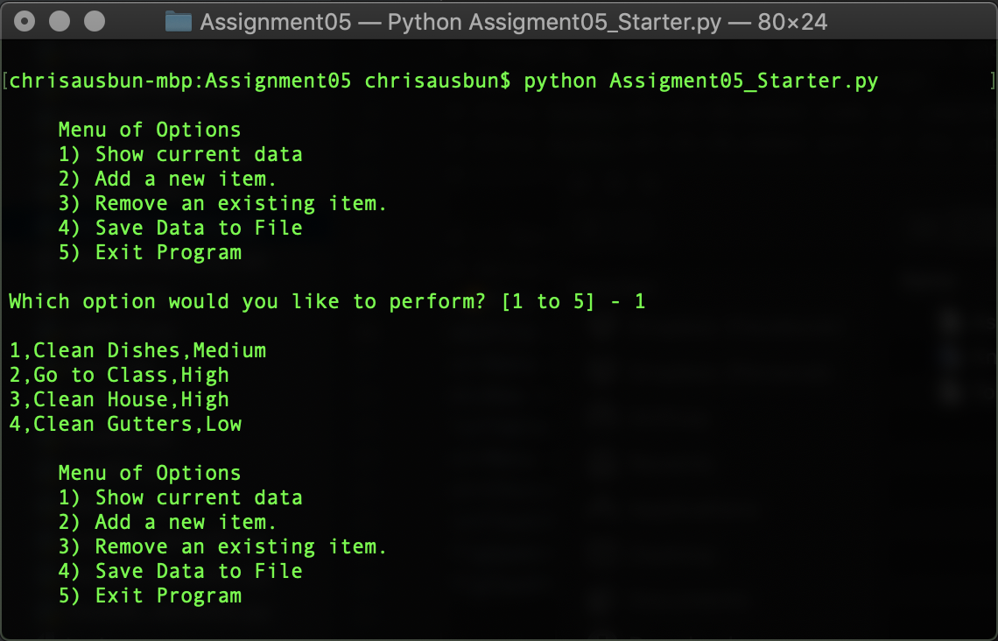

**Figure 6: Running in Terminal**

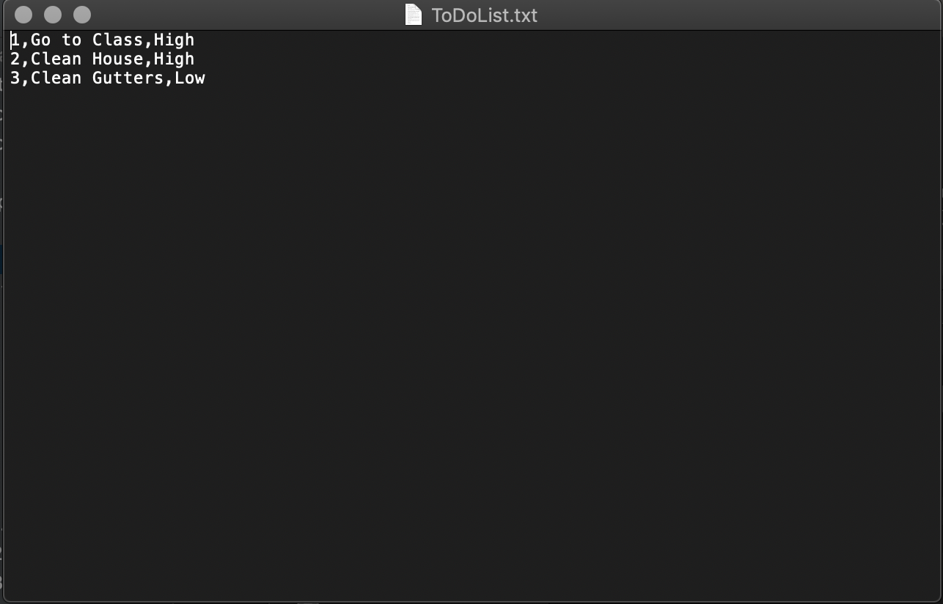

**Figure 7: Output .txt file**